Table 1. Summary statistics.
 | Obs. | Mean | Std. dev. | Min | Max
Granted Patent Applications (3-year window) | 2,820 | 3.239 | 22.264 | 0.000 | 797.000
VD | 2,820 | 0.500 | 0.500 | 0.000 | 1.000
Prior Patent | 2,820 | 0.172 | 0.378 | 0.000 | 1.000
Late Stage | 2,820 | 0.191 | 0.393 | 0.000 | 1.000
Total Funding at VD ($ millions) | 2,820 | 71.969 | 466.334 | 0.000 | 14448.377
Funding Rounds at VD | 2,820 | 4.093 | 2.061 | 0.000 | 21.000
Bio/Healthcare | 2,820 | 0.190 | 0.392 | 0.000 | 1.000
Hardware/Manufacturing/Deep Tech | 2,820 | 0.143 | 0.350 | 0.000 | 1.000
Soft/IT services | 2,820 | 0.407 | 0.491 | 0.000 | 1.000
California | 2,820 | 0.293 | 0.455 | 0.000 | 1.000
Massachusetts | 2,820 | 0.085 | 0.279 | 0.000 | 1.000
New York | 2,820 | 0.156 | 0.363 | 0.000 | 1.000
Note: This table reports summary statistics for the variables used in the analysis. The sample consists of 2,820 firm-level observations. For indicator variables, the mean represents the proportion of observations equal to one.

Table 2. Pairwise correlation
 |  | (1) | (2) | (3) | (4) | (5) | (6)
(1) | Granted Patent Applications (3-year filing window) | 1.000
(2) | VD | -0.056* | 1.000
(3) | Prior Patent | 0.262* | -0.015 | 1.000
(4) | Late Stage | 0.110* | -0.043* | 0.189* | 1.000
(5) | Total Funding at VD | 0.206* | 0.057* | 0.078* | 0.140* | 1.000
(6) | Funding Rounds at VD | 0.134* | -0.069* | 0.106* | 0.303* | 0.134* | 1.000
(7) | Bio/Healthcare | 0.020 | 0.010 | 0.196* | 0.030 | -0.026 | -0.043*
(8) | Hardware/Manufacturing/Deep Tech | 0.043* | -0.020 | 0.122* | -0.016 | 0.044* | 0.024
(9) | Soft/IT services | 0.007 | -0.005 | -0.114* | 0.000 | -0.009 | 0.070*
(10) | California | 0.097* | 0.014 | 0.088* | 0.118* | 0.062* | 0.059*
(11) | Massachusetts | 0.004 | -0.004 | 0.097* | 0.066* | -0.004 | 0.068*
(12) | New York | -0.048* | -0.013 | -0.085* | 0.001 | -0.001 | 0.007
Note: * indicates that the correlation is significantly different from zero at the 5% level (p-value < 0.05).

 |  | (7) | (8) | (9) | (10) | (11) | (12)
(7) | Bio/Healthcare | 1.000
(8) | Hardware/Manufacturing/Deep Tech | -0.198* | 1.000
(9) | Soft/IT services | -0.401* | -0.339* | 1.000
(10) | California | -0.049* | 0.024 | 0.065* | 1.000
(11) | Massachusetts | 0.139* | 0.006 | -0.060* | -0.196* | 1.000
(12) | New York | -0.108* | -0.069* | 0.033 | -0.276* | -0.131* | 1.000

TABLE 3. VD and post-VD patent quantity
DV: Log(Granted Patent Applications)(3-year window) | (1) | (2) | (3) | (4)
VD (H1) | -0.110*** | -0.069*** | -0.058** | -0.032
 | (0.000) | (0.001) | (0.020) | (0.166)
VD × Prior Patent (H2) |  | -0.236** |  | -0.188*
 |  | (0.025) |  | (0.069)
VD × Late Stage (H3) |  |  | -0.276*** | -0.242***
 |  |  | (0.000) | (0.001)
Prior Patent | 1.256*** | 1.370*** | 1.252*** | 1.344***
 | (0.000) | (0.000) | (0.000) | (0.000)
Late Stage | 0.053 | 0.049 | 0.180*** | 0.161***
 | (0.187) | (0.220) | (0.002) | (0.005)
Log(Total Funding at VD) | 0.024*** | 0.025*** | 0.025*** | 0.026***
 | (0.000) | (0.000) | (0.000) | (0.000)
Funding Rounds at VD | 0.011 | 0.011 | 0.012 | 0.012
 | (0.217) | (0.203) | (0.194) | (0.186)
Constant | -0.198** | -0.223** | -0.240** | -0.255**
 | (0.042) | (0.023) | (0.017) | (0.011)
Year FE | Yes | Yes | Yes | Yes
Region FE | Yes | Yes | Yes | Yes
Industry FE | Yes | Yes | Yes | Yes
Observations | 2,820 | 2,820 | 2,820 | 2,820
R-squared | 0.425 | 0.428 | 0.429 | 0.431
Note: This table reports regression results on the association between VD backing and post-VD innovation outcomes. The dependent variable is Log(Granted Patent Applications), measured as the log of one plus the number of patent applications filed during the three-year post-VD window (Years 1-3) that were ultimately granted. Patent counts are normalized for right truncation before the log transformation. VD equals 1 for VD-backed firms and 0 otherwise. Prior Patent and Late Stage are measured at the treatment reference year-the initial VD year for VD backed firms and the matched pseudo-treatment year for VC-only-backed control firms, and the interaction terms VD × Prior Patent and VD × Late Stage test heterogeneous VD effects. All models are firm-level matched-sampled regressions and include controls for funding, founding year, region and industry fixed effects. p-values are reported in parentheses.

TABLE 5. VD and post-VD patent quality
DV: Log(Normalized citations per patent)(3-year) | (1) | (2) | (3) | (4)
VD | -0.068** | -0.060 | -0.042 | -0.043
 | (0.042) | (0.246) | (0.298) | (0.421)
VD × Prior Patent |  | -0.015 |  | 0.002
 |  | (0.829) |  | (0.975)
VD × Late Stage |  |  | -0.097 | -0.097
 |  |  | (0.169) | (0.179)
Prior Patent | 0.053 | 0.059 | 0.054 | 0.053
 | (0.143) | (0.250) | (0.133) | (0.305)
Late Stage | -0.039 | -0.039 | -0.002 | -0.002
 | (0.365) | (0.367) | (0.973) | (0.976)
Log(Total Funding at VD) | 0.005 | 0.005 | 0.005 | 0.005
 | (0.466) | (0.459) | (0.456) | (0.461)
Funding Rounds at VD | -0.003 | -0.003 | -0.003 | -0.003
 | (0.700) | (0.700) | (0.738) | (0.738)
Constant | 0.232** | 0.227** | 0.217** | 0.218**
 | (0.019) | (0.029) | (0.028) | (0.035)
Region FE | Yes | Yes | Yes | Yes
Industry FE | Yes | Yes | Yes | Yes
Year FE | Yes | Yes | Yes | Yes
Observations | 710 | 710 | 710 | 710
R-squared | 0.034 | 0.034 | 0.036 | 0.036
Note: This table reports regression results where the dependent variable is Log(Normalized citations per patent), a forward-citation-based patent quality measure normalized within each filing-year cohort. For each patent filing-year, forward citations are scaled by the average citations of patents filed in the same year, then aggregated to the firm-year level and summed over patents filed during the three years after the VD or pseudo-treatment year and ultimately granted. p-values are reported in parentheses.

TABLE 6. Cumulative follow-on equity after VD
DV: Log(Follow-on Equity Raised)  (3-year) | (1) | (2) | (3) | (4)
VD | -0.074 | -0.082 | -0.117 | -0.116
 | (0.339) | (0.355) | (0.184) | (0.225)
VD × Prior Patent |  | 0.043 |  | -0.005
 |  | (0.810) |  | (0.976)
VD × Late Stage |  |  | 0.261 | 0.262
 |  |  | (0.189) | (0.192)
Prior Patent | 0.275*** | 0.255** | 0.275*** | 0.278**
 | (0.006) | (0.045) | (0.006) | (0.030)
Late Stage | 0.485*** | 0.486*** | 0.388** | 0.387**
 | (0.002) | (0.002) | (0.019) | (0.021)
Log(Total Funding at VD) | 0.490*** | 0.490*** | 0.489*** | 0.489***
 | (0.000) | (0.000) | (0.000) | (0.000)
Funding Rounds at VD | -0.101*** | -0.101*** | -0.102*** | -0.102***
 | (0.000) | (0.000) | (0.000) | (0.000)
Constant | 8.895*** | 8.899*** | 8.939*** | 8.939***
 | (0.000) | (0.000) | (0.000) | (0.000)
Region FE | Yes | Yes | Yes | Yes
Industry FE | Yes | Yes | Yes | Yes
Year FE | Yes | Yes | Yes | Yes
Observations | 1,627 | 1,627 | 1,627 | 1,627
R-squared | 0.397 | 0.397 | 0.398 | 0.398
Note: The table reports regression results when the dependent variable is Log(Follow-on Equity Raised), measured as the cumulative amount of follow-on equity financing raised within the three-year window after the initial VD event. The number of observations is smaller than the full firm sample because firms that exit, become defunct, or remain alive but raise no follow-on equity during the post-VD window are treated as missing for the dependent variable and excluded from the regression. p-values are in parentheses.

TABLE 7. Annual follow-on equity raised after VD
DV: Log(Annual Follow-on Equity Raised) | (1) | (2) | (3)
 | t+1 | t+2 | t+3
VD | -0.165* | 1.618*** | 0.666*
 | (0.082) | (0.001) | (0.084)
Prior Patent | 0.341*** | 1.457** | 0.336
 | (0.006) | (0.029) | (0.538)
Late Stage | 0.749*** | -0.284 | -0.620
 | (0.000) | (0.709) | (0.296)
Log(Total Funding at VD) | 0.455*** | 0.010 | 0.204**
 | (0.000) | (0.931) | (0.034)
Funding Rounds at VD | -0.119*** | 0.193 | -0.154*
 | (0.000) | (0.100) | (0.081)
Constant | 9.014*** | 3.863** | 1.738
 | (0.000) | (0.029) | (0.234)
Region FE | Yes | Yes | Yes
Industry FE | Yes | Yes | Yes
Year FE | Yes | Yes | Yes
Observations | 1,043 | 1,043 | 1,485
R-squared | 0.417 | 0.030 | 0.032
Note. This table reports regression results where the dependent variable is Log(Annual Subsequent Equity Raised), measured as the amount of follow-on equity financing raised in each Post-VD year from t+1 to t+3 (as shown in Columns (1)-(3), respectively). The regression sample varies by horizon and remains smaller than the full firm sample (N=2,820) because firms with no observed equity funding in a given post-VD year, as well as firms that exit or become defunct, are treated as missing for the dependent variable and excluded. The number of observations generally increases at longer horizons because additional firms have a funding event observed in later post-VD years. p-values are in parentheses.

TABLE 8. Cox proportional hazard models on exit outcomes
 | M&A |  | IPO |  | Defunct
 | (1) | (2) | (3) | (4) | (5) |  | (6)
VD | 0.147** | 0.181*** | 0.347** | 0.306* | 0.144 | 0.135
 | (0.035) | (0.010) | (0.043) | (0.084) | (0.247) | (0.279)
Prior Patent |  | -0.121 |  | 0.369** |  | -0.198
 |  | (0.237) |  | (0.045) |  | (0.296)
Late Stage |  | 0.321*** |  | 0.424** |  | 0.019
 |  | (0.001) |  | (0.038) |  | (0.923)
Log(Total Funding at VD) |  | 0.052*** |  | 0.551*** |  | -0.080***
 |  | (0.009) |  | (0.000) |  | (0.001)
Funding Rounds at VD |  | 0.013 |  | 0.028 |  | 0.028
 |  | (0.502) |  | (0.466) |  | (0.398)
Region FE | Yes | Yes | Yes | Yes | Yes | Yes
Industry FE | Yes | Yes | Yes | Yes | Yes | Yes
Year FE | Yes | Yes | Yes | Yes | Yes | Yes
# of failures | 846 | 846 | 141 | 141 | 266 | 266
Observations | 2,690 | 2,690 | 2,690 | 2,690 | 2,690 | 2,690
Note: This table reports Cox proportional hazard model results for M&A, IPO, and defunct outcomes. p-values are reported in parentheses.

Table 9. Staggered DiD estimates on granted patent application
DV: Patent applications | (1)  All firms | (2)  No prior patent | (3)  Prior patent | (4)  Seed–Series B | (5)  Series C+
Simple ATT | -0.191* | 0.030 | -0.788*** | -0.120 | -1.734
 | (0.085) | (0.794) | (0.000) | (0.377) | (0.260)
Aggregated event study ATT | -0.187** | -0.000 | -0.624*** | -0.122 | -2.002
 | (0.014) | (0.996) | (0.002) | (0.172) | (0.293)
Controls | Yes | Yes | Yes | Yes | Yes
Region FE | Yes | Yes | Yes | Yes | Yes
Industry FE | Yes | Yes | Yes | Yes | Yes
Observations | 81,274 | 76,865 | 69,484 | 74,533 | 66,588
Firms | 7,273 | 6,892 | 6,255 | 6,698 | 6,002
Control | Never treat | Never treat | Never treat | Never treat | Never treat
Note: Callaway–Sant’Anna staggered DiD estimates use never-treated firms as controls. The outcome is the annual count of ultimately granted patent applications adjusted for right truncation. The aggregated event-study ATT averages effects over event years 0–4. p-values are in parentheses.

Table 10. Callaway and Sant’Anna DID for the effect of VD on granted patent applications
Effect | Control group: | Never-treated | Control group: | Not-yet-treated
Simple-aggregated effect | -0.19* (0.11) |  | -0.19* (0.11)
Dynamic effects | Event time | ATT (SE) | Event time | ATT (SE)
 | −4 | -0.04 (0.05) | −4 | -0.05 (0.05)
 | −3 | 0.10 (0.07) | −3 | 0.10 (0.07)
 | −2 | 0.05 (0.06) | −2 | 0.04 (0.06)
 | −1 | 0.02 (0.06) | −1 | 0.01 (0.06)
 | 0 | 0.00 (0.06) | 0 | -0.00 (0.06)
 | 1 | -0.10* (0.06) | 1 | -0.11* (0.06)
 | 2 | -0.25*** (0.08) | 2 | -0.26*** (0.09)
 | 3 | -0.28** (0.11) | 3 | -0.28*** (0.11)
 | 4 | -0.30** (0.14) | 4 | -0.31** (0.14)
Dynamic-aggregated effect |  | -0.19** (0.08) |  | -0.19** (0.08)
Group-aggregated effect |  | -0.18** (0.09) |  | -0.18** (0.09)
Note: Callaway–Sant’Anna estimates compare never-treated and not-yet-treated control groups. Event time is measured relative to first VD receipt. Dynamic and group aggregates summarize effects across post-treatment event times and treatment cohorts, respectively. Standard errors are in parentheses.

Table 11. Staggered DiD Estimates on granted patent citations
DV: Patent citations | (1)  All firms | (2)  Seed–Series B | (3)  Series C+
Simple ATT | 0.062 | -0.140 | 0.318
 | (0.752) | (0.674) | (0.537)
Aggregated event study ATT | 0.057 | -0.137 | -0.159
 | (0.734) | (0.687) | (0.720)
Controls | Yes | Yes | Yes
Region FE | Yes | Yes | Yes
Industry FE | Yes | Yes | Yes
Observations | 8,263 | 7,244 | 6,508
Firms | 2,111 | 1,875 | 1,655
Control | Never treat | Never treat | Never treat
Note: Callaway–Sant’Anna staggered DiD estimates use never-treated firms as controls. The outcome measures forward citations to granted patents. The aggregated event-study ATT averages effects over event years 0–4. p-values are in parentheses.

Table 12. Callaway and Sant’Anna DID Effects for the effect of VD on granted patent citations
Effect | Control group: | Never-treated | Control group: | Not-yet-treated
Simple-aggregated effect | 0.06 (0.20) |  | 0.05 (0.19)
Dynamic effects | Event time | ATT (SE) | Event time | ATT (SE)
 | −4 | 0.75 (0.55) | −4 | 0.76 (0.55)
 | −3 | -0.54 (0.45) | −3 | -0.57 (0.47)
 | −2 | -0.04 (0.12) | −2 | -0.03 (0.11)
 | −1 | -0.02 (0.11) | −1 | -0.01 (0.11)
 | 0 | 0.11 (0.15) | 0 | 0.11 (0.14)
 | 1 | 0.12 (0.23) | 1 | 0.14 (0.23)
 | 2 | 0.04 (0.18) | 2 | 0.03 (0.18)
 | 3 | 0.06 (0.32) | 3 | 0.07 (0.33)
 | 4 | -0.05 (0.49) | 4 | -0.08 (0.47)
Dynamic-aggregated effect |  | 0.06 (0.17) |  | 0.05 (0.16)
Group-aggregated effect |  | 0.16 (0.20) |  | 0.15 (0.20)
Note: Callaway–Sant’Anna estimates compare never-treated and not-yet-treated control groups. Event time is measured relative to first VD receipt. Dynamic and group aggregates summarize effects across post-treatment event times and treatment cohorts, respectively. Standard errors are in parentheses.

Table 13. TWFE estimates of VD intensity and post-VD patent applications
DV: Log(Granted patent applications) | (1)  All firms | (2)  Prior int. | (3)  Late int. | (4)  Both int.
VD amount x Post | -0.000* | -0.000** | -0.000* | -0.000**
 | (0.099) | (0.016) | (0.097) | (0.020)
VD amount x Post x Prior patent |  | -0.000 |  | -0.000
 |  | (0.329) |  | (0.327)
VD amount x Post x Late stage |  |  | -0.000 | -0.000
 |  |  | (0.655) | (0.452)
Post x Prior patent |  | -0.119* |  | -0.119*
 |  | (0.087) |  | (0.086)
Post x Late stage |  |  | -0.011 | 0.005
 |  |  | (0.586) | (0.797)
Post | 0.024** | 0.039*** | 0.027** | 0.039***
 | (0.037) | (0.000) | (0.026) | (0.000)
Lagged prior patent | -0.045 | -0.006 | -0.046 | -0.006
 | (0.622) | (0.947) | (0.619) | (0.949)
Lagged late stage | -0.006 | -0.001 | -0.002 | -0.002
 | (0.718) | (0.948) | (0.910) | (0.915)
Log(Total lagged funding) | 0.003*** | 0.003** | 0.003*** | 0.003**
 | (0.010) | (0.011) | (0.010) | (0.011)
Log(Lagged funding rounds) | -0.029 | -0.032* | -0.029 | -0.031*
 | (0.124) | (0.088) | (0.122) | (0.095)
Firm FE | Yes | Yes | Yes | Yes
Year FE | Yes | Yes | Yes | Yes
Observations | 7,139 | 7,139 | 7,139 | 7,139
Firms | 841 | 841 | 841 | 841
Within R² | 0.013 | 0.024 | 0.013 | 0.024
Note: TWFE regressions relate VD amount to post-VD log granted patent applications, including firm and year fixed effects and lagged controls. Post equals one from the first VD year onward. p-values are in parentheses.

Table 14. TWFE estimates of VD intensity and post-VD patent applications
DV: Log(Granted patent applications) | (1)  All firms | (2)  Prior int. | (3)  Late int. | (4)  Both int.
VD-to-prior equity round ratio x Post | 0.000 | 0.000 | 0.000 | 0.000
 | (0.153) | (0.776) | (0.183) | (0.786)
VD-to-prior equity round ratio x Post x Prior patent |  | -0.037 |  | -0.037
 |  | (0.409) |  | (0.408)
VD-to-prior equity round ratio x Post x Late stage |  |  | 0.001 | 0.000
 |  |  | (0.629) | (0.755)
Post x Prior patent |  | -0.142* |  | -0.141*
 |  | (0.094) |  | (0.095)
Post x Late stage |  |  | -0.015 | -0.002
 |  |  | (0.493) | (0.922)
Post | 0.025* | 0.044*** | 0.028** | 0.044***
 | (0.067) | (0.000) | (0.044) | (0.000)
Lagged prior patent | -0.029 | 0.022 | -0.029 | 0.022
 | (0.785) | (0.842) | (0.784) | (0.843)
Lagged late stage | -0.006 | -0.002 | -0.001 | -0.001
 | (0.751) | (0.928) | (0.953) | (0.956)
Log(Total lagged funding amount) | 0.005*** | 0.005*** | 0.005*** | 0.005***
 | (0.006) | (0.008) | (0.006) | (0.008)
Log(number of lagged funding rounds) | -0.046** | -0.048** | -0.047** | -0.048**
 | (0.030) | (0.020) | (0.029) | (0.021)
Firm FE | Yes | Yes | Yes | Yes
Year FE | Yes | Yes | Yes | Yes
Observations | 5,889 | 5,889 | 5,889 | 5,889
Firms | 685 | 685 | 685 | 685
Within R² | 0.015 | 0.031 | 0.015 | 0.031
Note: VD intensity is measured as the initial VD amount divided by the preceding equity-round amount. TWFE models include firm and year fixed effects and lagged controls. Post equals one from the first VD year onward. p-values are in parentheses.

TABLE A1. 2SLS regressions of main results
 | (1) | (2)
 | Log(Granted Patent Applications)  (3-year filing window) | VD
Log(Regional VD Amount Deployed) |  | 0.051***
 |  | (0.000)
Instrumented VD | -0.708***
 | (0.009)
Prior Patent | 1.245*** | -0.017
 | (0.000) | (0.518)
Late Stage | 0.019 | -0.062**
 | (0.668) | (0.020)
Log(Total Funding at VD) | 0.032*** | 0.010**
 | (0.000) | (0.034)
Funding Rounds at VD | 0.000 | -0.018***
 | (0.972) | (0.000)
Region FE | Yes | Yes
Industry FE | Yes | Yes
Year FE | Yes | Yes
Observations | 2,820 | 2,820
F-stat | 108.575 | 10.595
R-squared | 0.222 | 0.018
Cragg-Donald Wald F-stat | 23.823
Note: This table reports 2SLS regression results. Column (2) presents the first-stage regression predicting VD, and Column (1) presents the second-stage regression using instrumented VD. p-values are reported in parentheses.

TABLE A2. Replication of main results among patenting startups
DV: Log(Granted Patent Applications)  (3-year window) | (1) | (2) | (3) | (4)
VD (H1) | -0.134** | -0.002 | -0.024 | 0.062
 | (0.028) | (0.978) | (0.718) | (0.424)
VD × Prior Patent (H2) |  | -0.239** |  | -0.175
 |  | (0.045) |  | (0.141)
VD × Late Stage (H3) |  |  | -0.406*** | -0.368**
 |  |  | (0.006) | (0.012)
Prior Patent | 0.611*** | 0.711*** | 0.616*** | 0.689***
 | (0.000) | (0.000) | (0.000) | (0.000)
Late Stage | 0.028 | 0.030 | 0.185* | 0.172
 | (0.754) | (0.735) | (0.094) | (0.119)
Log(Total Funding at VD) | 0.082*** | 0.084*** | 0.082*** | 0.084***
 | (0.000) | (0.000) | (0.000) | (0.000)
Funding Rounds at VD | 0.021 | 0.021 | 0.022 | 0.022
 | (0.332) | (0.328) | (0.282) | (0.283)
Constant | -0.105 | -0.189 | -0.170 | -0.226
 | (0.744) | (0.571) | (0.612) | (0.513)
Region FE | Yes | Yes | Yes | Yes
Industry FE | Yes | Yes | Yes | Yes
Year FE | Yes | Yes | Yes | Yes
Observations | 710 | 710 | 710 | 710
R-squared | 0.273 | 0.277 | 0.282 | 0.284
Note: This table presents a robustness check for Table 3 by restricting the sample to patenting firms only, defined as firms with at least one patent application that was ultimately granted. The results are qualitatively similar when we restrict the analysis to firms with at least one granted patent application. In particular, the direction and relative pattern of the estimated effects for H1–H3 remain consistent, although statistical significance is attenuated due to the reduced sample size, N=710.

TABLE A3. VD and funding stage heterogeneity
DV: Log(Granted Patent Applications)(3-year window) | (1) | (2) | (3) | (4)
VD | -0.113*** | -0.072*** | -0.046 | -0.029
 | (0.000) | (0.000) | (0.160) | (0.358)
VD × Prior Patent |  | -0.235** |  | -0.185*
 |  | (0.025) |  | (0.075)
VD × Series A |  |  | 0.004 | 0.016
 |  |  | (0.937) | (0.776)
VD × Series B |  |  | -0.068 | -0.047
 |  |  | (0.312) | (0.485)
VD × Series C+ |  |  | -0.288*** | -0.246***
 |  |  | (0.000) | (0.001)
Prior Patent | 1.257*** | 1.371*** | 1.254*** | 1.344***
 | (0.000) | (0.000) | (0.000) | (0.000)
Series A | -0.004 | 0.000 | 0.001 | -0.003
 | (0.907) | (0.999) | (0.977) | (0.944)
Series B | -0.043 | -0.040 | -0.004 | -0.013
 | (0.291) | (0.321) | (0.947) | (0.817)
Series C+ | 0.034 | 0.033 | 0.174*** | 0.152**
 | (0.472) | (0.486) | (0.006) | (0.015)
Log(Total Funding at VD) | 0.027*** | 0.027*** | 0.027*** | 0.027***
 | (0.000) | (0.000) | (0.000) | (0.000)
Funding Rounds at VD | 0.012 | 0.012 | 0.012 | 0.012
 | (0.206) | (0.196) | (0.180) | (0.176)
Constant | -0.227** | -0.250** | -0.269** | -0.278**
 | (0.037) | (0.022) | (0.017) | (0.013)
Year FE | Yes | Yes | Yes | Yes
Region FE | Yes | Yes | Yes | Yes
Industry FE | Yes | Yes | Yes | Yes
Observations | 2,820 | 2,820 | 2,820 | 2,820
R-squared | 0.425 | 0.428 | 0.429 | 0.431
Note: Funding stage is classified as Seed/pre-Series (the reference category), Series A, Series B, or Series C and above, based on the highest observed financing series by the VD year or reference date. Where prior series information is unavailable, stage is inferred by stepping back one stage from the first subsequent observed series. The VD × Series interactions capture differences in the VD association relative to Seed/pre-Series firms. All models are firm-level matched-sampled regressions and include controls for funding, founding year, region and industry fixed effects. p-values are reported in parentheses.

TABLE A4. VD and downstream subsequent equity financing

Panel A. Probability of raising equity
DV: Prob(Raising equity) | (1)  Within 1 year | (2)  Within 2 years | (3)  Within 3 years
VD | -0.015 | -0.032 | -0.046**
 | (0.401) | (0.104) | (0.019)
Prior Patent | 0.059** | 0.042 | 0.060**
 | (0.026) | (0.126) | (0.026)
Late Stage | -0.039 | -0.081*** | -0.071**
 | (0.139) | (0.005) | (0.018)
Log(Total Funding at VD) | -0.006 | 0.007 | 0.010*
 | (0.223) | (0.189) | (0.058)
Funding Rounds at VD | 0.005 | 0.002 | -0.003
 | (0.285) | (0.734) | (0.577)
Constant | 0.446*** | 0.467*** | 0.496***
 | (0.000) | (0.000) | (0.000)
Region FE | Yes | Yes | Yes
Industry FE | Yes | Yes | Yes
Year FE | Yes | Yes | Yes
Observations | 2,755 | 2,630 | 2,497
R-squared | 0.011 | 0.015 | 0.015

Panel B. Timing and size of the next equity round
 | (1)  Next round hazard | (2)  Time to next round | (3)  Amount raised
VD | -0.134*** | 0.164** | -0.312***
 | (0.008) | (0.013) | (0.000)
Prior Patent | 0.155** | -0.203** | 0.176
 | (0.028) | (0.029) | (0.104)
Late Stage | -0.225*** | 0.294*** | 0.618***
 | (0.003) | (0.003) | (0.000)
Log(Total Funding at VD) | 0.009 | -0.016 | 0.463***
 | (0.494) | (0.379) | (0.000)
Funding Rounds at VD | 0.009 | -0.011 | -0.114***
 | (0.474) | (0.527) | (0.000)
Constant |  | 7.341*** | 8.995***
 |  | (0.000) | (0.000)
Region FE | Yes | Yes | Yes
Industry FE | Yes | Yes | Yes
Year FE | Yes | Yes | Yes
Observations | 2,755 | 2,755 | 1,260
R-squared |  |  | 0.419

Panel C. Cumulative equity raised
DV: Log(Cumulative equity raised) | (1)  Within 1 year | (2)  Within 2 years | (3)  Within 3 years
VD | -0.024 | -0.485 | -0.785**
 | (0.936) | (0.158) | (0.032)
Prior Patent | 1.208*** | 1.013** | 1.534***
 | (0.008) | (0.044) | (0.004)
Late Stage | -0.566 | -1.323** | -1.153**
 | (0.212) | (0.013) | (0.049)
Log(Total Funding at VD) | 0.082 | 0.422*** | 0.504***
 | (0.310) | (0.000) | (0.000)
Funding Rounds at VD | 0.020 | -0.069 | -0.219**
 | (0.804) | (0.454) | (0.033)
Constant | 3.626*** | 1.817 | 2.122
 | (0.004) | (0.229) | (0.228)
Region FE | Yes | Yes | Yes
Industry FE | Yes | Yes | Yes
Year FE | Yes | Yes | Yes
Observations | 2,540 | 2,273 | 2,051
R-squared | 0.013 | 0.031 | 0.034

TABLE A5. VD and post-VD treatment firm size (Number of Employees), t+1 to t+3
DV: Number of Employees |  | (1) |  | (2) |  | (3) |  | (4) |  | (5)
VD | 63.947** |  | 42.507* |  | 28.834 |  | -8.424 |  | -13.591
 | (0.025) |  | (0.056) |  | (0.197) |  | (0.631) |  | (0.516)
VD×Prior Patent_VD |  |  |  |  | 81.116 |  |  |  | 35.613
 |  |  |  |  | (0.369) |  |  |  | (0.678)
VD×Late Stage_VD |  |  |  |  |  |  | 323.050*** |  | 317.748***
 |  |  |  |  |  |  | (0.003) |  | (0.003)
Prior Patent_VD |  |  | 58.598 |  | 23.749 |  | 60.357 |  | 45.029
 |  |  | (0.197) |  | (0.509) |  | (0.175) |  | (0.203)
Late Stage_VD |  |  | 160.265*** |  | 161.620*** |  | 22.915 |  | 25.764
 |  |  | (0.001) |  | (0.001) |  | (0.567) |  | (0.517)
Log(Total Funding Amt_VD) |  |  | 43.878*** |  | 43.418*** |  | 41.145*** |  | 40.988***
 |  |  | (0.000) |  | (0.000) |  | (0.000) |  | (0.000)
Num of Funding Rounds_VD |  |  | -5.409 |  | -5.676 |  | -6.932 |  | -7.025
 |  |  | (0.511) |  | (0.488) |  | (0.379) |  | (0.373)
Constant | 113.603*** |  | -550.559*** |  | -538.697*** |  | -494.406*** |  | -490.119***
 | (0.000) |  | (0.001) |  | (0.001) |  | (0.002) |  | (0.002)
Region FE | Yes |  | Yes |  | Yes |  | Yes |  | Yes
Industry FE | Yes |  | Yes |  | Yes |  | Yes |  | Yes
VD Year FE | Yes |  | Yes |  | Yes |  | Yes |  | Yes
Year FE | Yes |  | Yes |  | Yes |  | Yes |  | Yes
Observations | 611 |  | 611 |  | 611 |  | 611 |  | 611
R-squared | 0.010 |  | 0.209 |  | 0.211 |  | 0.241 |  | 0.242
Note: This table reports regression results on firm size growth measured by the number of employees, using the pooled t+1 to t+3 year post-VD window and restricting the sample to private firms. All models include the listed controls, and absorb VD-year fixed effects and Founding year fixed effects. p-values are in parentheses.

TABLE A6. Pooled post-VD revenue by VD, t+1 to t+3
VD=0 |  |  | VD=1
N | Mean | SD | N | Mean | SD | t | p
19 | 33,488,421 | 71,010,976 | 98 | 83,707,381 | 314,246,793 | -1.408 | 0.162
Note: This table reports pooled summary statistics for post-VD revenue over t+1 to t+3 for an expanded private-firm sample. The sample incorporates revenue observations from Pitchbook and supplementary revenue data collected from external sources, increasing the number of firms with observed revenue, especially among VD-backed firms.

TABLE A7. Annual post-VD revenue by VD, t+1 to t+3
VD=0 |  |  |  | VD=1
Year | N | Mean | SD | N | Mean | SD |  | t | df |  | p
t+1 | 3 | 15,666,667 | 12,472,904 | 20 | 34,890,000 | 91,473,672 |  | -0.886 | 20.945 |  | 0.385
t+2 | 5 | 25,480,000 | 34,914,280 | 31 | 80,248,384 | 141,894,640 |  | -1.832 | 27.591 |  | 0.078
t+3 | 11 | 41,989,092 | 91,384,072 | 47 | 106,762,200 | 435,960,512 |  | -0.935 | 55.840 |  | 0.354
Note: This table reports year-by-year summary statistics for post-VD revenue in t+1, t+2, and t+3 after treatment reference year, using an expanded private-firm sample that supplements Pitchbook revenue observations with additional revenue data collected from external sources. For each post-VD treatment year, the table compares VD-backed firms and VC-only-backed firms. The mean difference is evaluated using a two-sample t-test with corresponding t, df, and p values.

TABLE A8. Gunning fog readability
DV: Mean Gunning Fog | (1) | (2) | (3) | (4)
VD | -0.323* | -0.189 | -0.260 | -0.154
 | (0.051) | (0.476) | (0.207) | (0.580)
VD x Prior Patent |  | -0.248 |  | -0.215
 |  | (0.453) |  | (0.521)
VD x Late Stage |  |  | -0.249 | -0.203
 |  |  | (0.459) | (0.551)
Prior Patent | 0.028 | 0.131 | 0.030 | 0.119
 | (0.878) | (0.576) | (0.868) | (0.615)
Late Stage | -0.062 | -0.060 | 0.026 | 0.011
 | (0.760) | (0.768) | (0.917) | (0.963)
Log(Total Funding at VD) | 0.045 | 0.047 | 0.046 | 0.047
 | (0.336) | (0.326) | (0.327) | (0.320)
Funding Rounds at VD | 0.004 | 0.004 | 0.005 | 0.005
 | (0.924) | (0.923) | (0.900) | (0.903)
Constant | 17.775*** | 17.699*** | 17.723*** | 17.666***
 | (0.000) | (0.000) | (0.000) | (0.000)
Founding-year FE | Yes | Yes | Yes | Yes
Region FE | Yes | Yes | Yes | Yes
Industry FE | Yes | Yes | Yes | Yes
Observations | 695 | 695 | 695 | 695
R-squared | 0.040 | 0.041 | 0.040 | 0.041
Note: The dependent variable is the average Gunning Fog index of patent descriptions for ultimately granted applications filed in years t+1 to t+3 post VD. Each patent’s index is calculated as 0.4 × [(words/sentences) + 100 × (complex words/words)], where complex words have three or more syllables. Higher values indicate more years of education required to understand the text and thus lower readability.

TABLE A9. Automated readability index
DV: Mean Automated Readability Index | (1) | (2) | (3) | (4)
VD | -0.445** | -0.224 | -0.365 | -0.184
 | (0.021) | (0.474) | (0.121) | (0.571)
VD x Prior Patent |  | -0.407 |  | -0.369
 |  | (0.294) |  | (0.350)
VD x Late Stage |  |  | -0.313 | -0.235
 |  |  | (0.444) | (0.574)
Prior Patent | -0.001 | 0.168 | 0.002 | 0.154
 | (0.996) | (0.565) | (0.994) | (0.602)
Late Stage | 0.173 | 0.176 | 0.284 | 0.259
 | (0.481) | (0.474) | (0.352) | (0.400)
Log(Total Funding at VD) | -0.003 | 0.000 | -0.001 | 0.000
 | (0.962) | (0.994) | (0.983) | (0.993)
Funding Rounds at VD | -0.013 | -0.013 | -0.011 | -0.012
 | (0.773) | (0.776) | (0.798) | (0.794)
Constant | 14.857*** | 14.732*** | 14.790*** | 14.694***
 | (0.000) | (0.000) | (0.000) | (0.000)
Founding-year FE | Yes | Yes | Yes | Yes
Region FE | Yes | Yes | Yes | Yes
Industry FE | Yes | Yes | Yes | Yes
Observations | 695 | 695 | 695 | 695
R-squared | 0.043 | 0.045 | 0.044 | 0.045
Note: The dependent variable is the average Automated Readability Index (ARI) of patent descriptions for ultimately granted applications filed in years t+1 to t+3 after VD. Each patent’s ARI is calculated as 4.71 × (characters/words) + 0.5 × (words/sentences) − 21.43. Higher values indicate a higher U.S. grade level required to understand the text and thus lower readability.

TABLE A10. Negative Flesch reading ease
DV: Mean Negative Flesch Reading Ease | (1) | (2) | (3) | (4)
VD | -1.360* | -0.723 | -1.275 | -0.709
 | (0.052) | (0.521) | (0.142) | (0.552)
VD x Prior Patent |  | -1.172 |  | -1.159
 |  | (0.404) |  | (0.413)
VD x Late Stage |  |  | -0.331 | -0.085
 |  |  | (0.816) | (0.953)
Prior Patent | -0.093 | 0.393 | -0.090 | 0.388
 | (0.902) | (0.691) | (0.905) | (0.697)
Late Stage | -0.140 | -0.131 | -0.023 | -0.101
 | (0.870) | (0.879) | (0.983) | (0.923)
Log(Total Funding at VD) | 0.197 | 0.203 | 0.199 | 0.204
 | (0.360) | (0.349) | (0.358) | (0.350)
Funding Rounds at VD | -0.054 | -0.054 | -0.053 | -0.054
 | (0.735) | (0.737) | (0.742) | (0.738)
Constant | -34.900*** | -35.259*** | -34.970*** | -35.273***
 | (0.000) | (0.000) | (0.000) | (0.000)
Founding-year FE | Yes | Yes | Yes | Yes
Region FE | Yes | Yes | Yes | Yes
Industry FE | Yes | Yes | Yes | Yes
Observations | 695 | 695 | 695 | 695
R-squared | 0.054 | 0.055 | 0.054 | 0.055
Note: The dependent variable is the average negative Flesch Reading Ease score of patent descriptions for ultimately granted applications filed in years t+1 to t+3 after VD. Each patent’s score is calculated as −[206.835 − 1.015 × (words/sentences) − 84.6 × (syllables/words)]. Multiplying the original score by −1 makes higher values indicate lower readability.

TABLE A11. Patents in new technological domains
DV: Log(1 + New domain patents) | (1) | (2) | (3) | (4)
VD | -0.070 | -0.076 | -0.034 | -0.049
 | (0.329) | (0.267) | (0.697) | (0.543)
VD x Prior Patent |  | 0.011 |  | 0.038
 |  | (0.938) |  | (0.786)
VD x Late Stage |  |  | -0.103 | -0.113
 |  |  | (0.504) | (0.476)
Prior Patent | 0.364*** | 0.359*** | 0.361*** | 0.344***
 | (0.000) | (0.001) | (0.000) | (0.001)
Late Stage | -0.141* | -0.141* | -0.090 | -0.084
 | (0.096) | (0.097) | (0.450) | (0.485)
Log(Total Funding at VD) | 0.042* | 0.042* | 0.041* | 0.041*
 | (0.078) | (0.079) | (0.081) | (0.084)
Funding Rounds at VD | 0.037 | 0.037 | 0.037 | 0.037
 | (0.307) | (0.307) | (0.308) | (0.308)
Constant | -0.579 | -0.576 | -0.581 | -0.570
 | (0.165) | (0.171) | (0.162) | (0.172)
Founding-year FE | Yes | Yes | Yes | Yes
Region FE | Yes | Yes | Yes | Yes
Industry FE | Yes | Yes | Yes | Yes
Observations | 402 | 402 | 402 | 402
R-squared | 0.137 | 0.137 | 0.138 | 0.138
Note: The dependent variable is Log(number of new domain patents), counting ultimately granted applications filed in years t+1 to t+3 after VD whose primary three-digit CPC class is absent from the firm’s pre-VD granted patent portfolio. The pre-VD portfolio is held fixed throughout the window. Higher values indicate greater entry into technological domains beyond the firm’s existing knowledge base.

TABLE A11. Patents in existing technological domains
DV: Log(Existing domain patents) | (1) | (2) | (3) | (4)
VD | -0.235** | -0.528** | -0.107 | -0.434
 | (0.015) | (0.049) | (0.427) | (0.116)
VD x Prior Patent |  | 0.361 |  | 0.443
 |  | (0.210) |  | (0.119)
VD x Late Stage |  |  | -0.274 | -0.340*
 |  |  | (0.151) | (0.070)
Prior Patent | 1.256*** | 1.108*** | 1.249*** | 1.064***
 | (0.000) | (0.000) | (0.000) | (0.000)
Late Stage | -0.198* | -0.195* | -0.078 | -0.045
 | (0.080) | (0.088) | (0.588) | (0.757)
Log(Total Funding at VD) | 0.208*** | 0.210*** | 0.205*** | 0.207***
 | (0.000) | (0.000) | (0.000) | (0.000)
Funding Rounds at VD | -0.002 | -0.002 | -0.003 | -0.004
 | (0.913) | (0.915) | (0.821) | (0.811)
Constant | -4.275*** | -4.195*** | -4.265*** | -4.166***
 | (0.000) | (0.000) | (0.000) | (0.000)
Founding-year FE | Yes | Yes | Yes | Yes
Region FE | Yes | Yes | Yes | Yes
Industry FE | Yes | Yes | Yes | Yes
Observations | 402 | 402 | 402 | 402
Pseudo R-squared | 0.217 | 0.219 | 0.219 | 0.221
Note: The dependent variable is Log(number of existing domain patents), counting ultimately granted applications filed in years t+1 to t+3 after VD whose primary three-digit CPC class is already present in the firm’s pre-VD granted patent portfolio. The pre-VD portfolio is held fixed throughout the window. Higher values indicate greater technological development within the firm’s existing knowledge base.

TABLE A12. Entry into New CPC Classes
DV: Number of New Primary CPC3 Classes | (1) | (2) | (3) | (4)
VD | -0.356 | -0.615* | -0.308 | -0.579
 | (0.104) | (0.093) | (0.221) | (0.123)
VD x Prior Patent |  | 0.335 |  | 0.383
 |  | (0.433) |  | (0.375)
VD x Late Stage |  |  | -0.129 | -0.199
 |  |  | (0.775) | (0.664)
Prior Patent | 1.162*** | 1.042*** | 1.161*** | 1.020***
 | (0.000) | (0.001) | (0.000) | (0.001)
Late Stage | -0.658** | -0.659** | -0.605* | -0.577
 | (0.013) | (0.013) | (0.089) | (0.108)
Log(Total Funding at VD) | 0.196** | 0.199** | 0.194** | 0.197**
 | (0.025) | (0.028) | (0.027) | (0.031)
Funding Rounds at VD | 0.070* | 0.070* | 0.069* | 0.069*
 | (0.068) | (0.070) | (0.072) | (0.074)
Constant | -4.658*** | -4.617*** | -4.641*** | -4.585***
 | (0.001) | (0.001) | (0.001) | (0.002)
Founding-year FE | Yes | Yes | Yes | Yes
Region FE | Yes | Yes | Yes | Yes
Industry FE | Yes | Yes | Yes | Yes
Observations | 402 | 402 | 402 | 402
Pseudo R-squared | 0.156 | 0.157 | 0.156 | 0.157
Note: The dependent variable counts distinct primary three-digit CPC classes in ultimately granted applications filed in years t+1 to t+3 after VD that are absent from the firm’s fixed pre-VD granted patent portfolio. Each new class is counted once, regardless of the number of patents in that class. Higher values indicate entry into a wider range of new technological domains.

TABLE A13. Backward Citation Technological Breadth
DV: Backward cited CPC3 classes | (1) | (2) | (3) | (4)
VD | 0.398* | -0.073 | 0.205 | -0.182
 | (0.080) | (0.787) | (0.388) | (0.523)
VD x Prior Patent |  | 0.959** |  | 0.880**
 |  | (0.022) |  | (0.034)
VD x Late Stage |  |  | 0.700 | 0.536
 |  |  | (0.234) | (0.359)
Prior Patent | 0.358* | -0.032 | 0.355* | -0.002
 | (0.074) | (0.881) | (0.077) | (0.991)
Late Stage | 0.312 | 0.298 | 0.072 | 0.116
 | (0.302) | (0.322) | (0.793) | (0.675)
Log(Total Funding at VD) | -0.066 | -0.066 | -0.070 | -0.069
 | (0.244) | (0.265) | (0.224) | (0.248)
Funding Rounds at VD | 0.026 | 0.023 | 0.022 | 0.020
 | (0.640) | (0.668) | (0.696) | (0.710)
Constant | 2.918*** | 3.118*** | 3.095*** | 3.236***
 | (0.001) | (0.001) | (0.001) | (0.001)
Founding-year FE | Yes | Yes | Yes | Yes
Region FE | Yes | Yes | Yes | Yes
Industry FE | Yes | Yes | Yes | Yes
Observations | 494 | 494 | 494 | 494
R-squared | 0.046 | 0.057 | 0.051 | 0.060
Note: The dependent variable is the average number of distinct three-digit CPC classes represented in each patent’s backward citations, calculated across ultimately granted applications filed in years t+1 to t+3 after VD. Each cited class is counted once per focal patent. Higher values indicate that the firm’s inventions draw on a broader range of technological knowledge.

TABLE A14. Total Self Citations
DV: Log(Total self-citations) | (1) | (2) | (3) | (4)
VD | 0.174 | -0.219 | 0.140 | -0.226
 | (0.309) | (0.387) | (0.383) | (0.428)
VD x Prior Patent |  | 0.482 |  | 0.477
 |  | (0.163) |  | (0.140)
VD x Late Stage |  |  | 0.076 | 0.025
 |  |  | (0.826) | (0.939)
Prior Patent | 1.069*** | 0.880*** | 1.068*** | 0.882***
 | (0.000) | (0.000) | (0.000) | (0.000)
Late Stage | 0.673*** | 0.669*** | 0.637** | 0.657**
 | (0.003) | (0.003) | (0.032) | (0.024)
Log(Total Funding at VD) | 0.004 | 0.001 | 0.004 | 0.001
 | (0.917) | (0.975) | (0.916) | (0.974)
Funding Rounds at VD | -0.048 | -0.047 | -0.048 | -0.047
 | (0.108) | (0.114) | (0.101) | (0.108)
Constant | -0.418 | -0.222 | -0.399 | -0.218
 | (0.489) | (0.713) | (0.512) | (0.721)
Founding-year FE | Yes | Yes | Yes | Yes
Region FE | Yes | Yes | Yes | Yes
Industry FE | Yes | Yes | Yes | Yes
Observations | 695 | 695 | 695 | 695
Pseudo R-squared | 0.196 | 0.199 | 0.196 | 0.199
Note: The dependent variable is Log(total self-citations), where self-citations are backward citations to the firm’s own patents. These citations are summed across ultimately granted applications filed in years t+1 to t+3 after VD. Higher values indicate greater use of the firm’s own prior patented knowledge.

TABLE A15. Assessing Balance Properties After Matching
 | Original Sample |  |  |  |  |  | Matched Sample
 | Treatment |  | Control |  | Diff. in Means |  | Treatment | Control | Diff. in Means
Founding Year |  | 2012.4 |  | 2012.9 |  | 0.5  [0.000] | 2012.4 | 2012.5 | 0.1  [0.460]
VD Year |  | 2017.4 |  | 2017.9 |  | 0.5  [0.000] | 2017.4 | 2017.5 | 0.1  [0.357]
Time To First VC |  | 1.595 |  | 1.893 |  | 0.298  [0.000] | 1.595 | 1.533 | -0.062  [0.354]
Funding Rounds at VD |  | 4.153 |  | 3.443 |  | -0.709  [0.000] | 4.153 | 4.133 | -0.019  [0.815]
Log(Total Funding at VD) |  | 16.015 |  | 15.704 |  | -0.311  [0.000] | 16.015 | 16.013 | -0.002  [0.973]
Pre-Granted Patent Applications |  | 2.806 |  | 2.209 |  | -0.596  [0.125] | 2.806 | 3.170 | 0.364  [0.541]
Region |  | 2.784 |  | 2.506 |  | -0.278  [0.000] | 2.784 | 2.772 | -0.011  [0.818]
Industry |  | 3.853 |  | 3.942 |  | 0.088  [0.012] | 3.853 | 3.849 | -0.004  [0.923]
Note: This table presents the balance of key matching covariates between the treatment (VD-backed firms) and control (VC-only-backed firms without VD) groups before and after propensity score matching (PSM). For each variable, means are reported for both groups in the original (unmatched) and matched samples, along with the difference in means. The values in brackets indicate p-values from t-tests comparing group means. For categorical variables such as industry and region, in addition to mean differences, we also confirm that the distribution of these variables is identical between groups after matching (p = 1). In the matched sample, all differences in means are zero or close to zero, and all p-values indicate no statistically significant differences. This confirms that observable characteristics are balanced between the treatment and control groups following PSM.

TABLE A16. Comparison of Funding Timelines of VD- and VC-Backed Firms
VD Backing | N | Time To First VD | Time To First VC | Time Between VC VD
1 | 1440 | 4.992 | 1.662 | 3.330
0 | 5876 |  | 2.105
Note: This table presents a comparison of funding timelines and sequences between VD- and VC-backed firms. The sample consists of 7,316 firms before matching, of which 1,440 received VD funding and 5,876 did not. Time To First VD represents the average number of years from firm founding to the first VD funding event. Time To First VC reports the average number of years from firm founding to the first VC funding event. Time Between VC VD shows the average number of years between the first VC funding and the first VD funding for VD-backed firms. The periods are expressed in years and are rounded to three decimal places. Missing values, denoted by '.', indicate that the measure is not applicable for firms without VD backing.

FIGURE A1. Kernel Density Plot of Propensity Scores for Treated and Control Groups

- Before Matching: Limited Overlap in Propensity Score Distributions
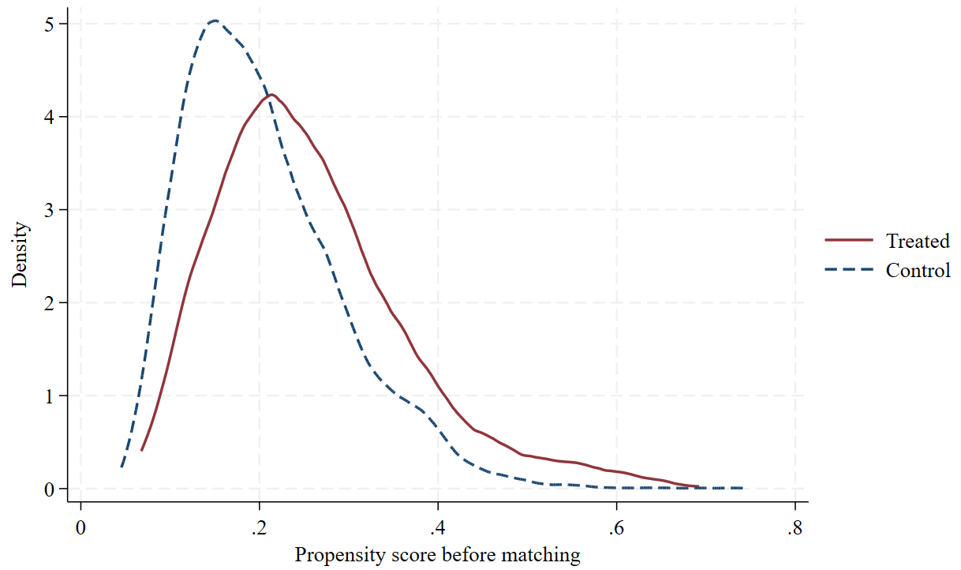
- After Matching: Increased Overlap and Improved Covariate Balance
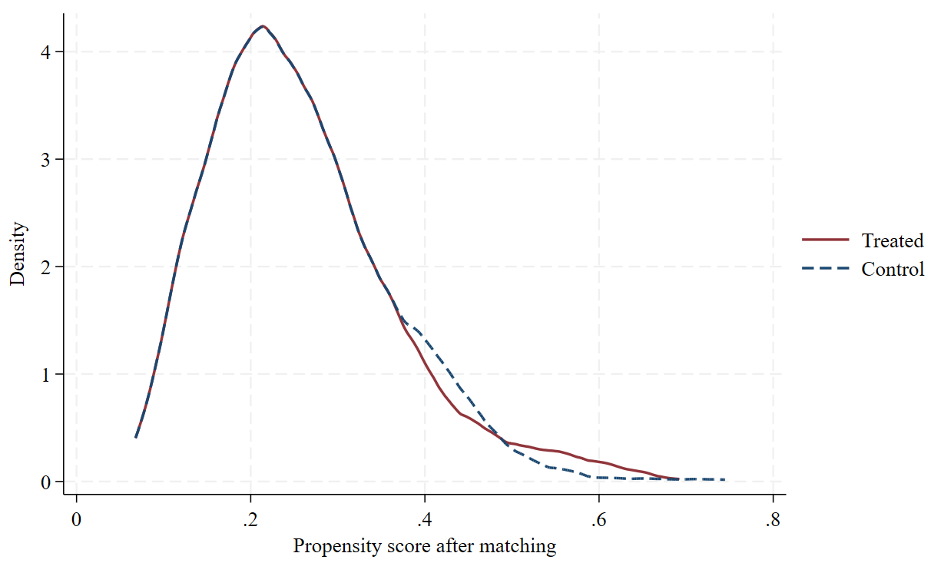
Note: Kernel density plots above illustrate the distribution of propensity scores for treated and control groups before and after matching. The goal of PSM is to increase the overlap between groups after matching, indicating improved covariable balance (Guo & Fraser, 2014; Stuart, 2010). Greater overlap after matching, as seen in (B), suggests that matched samples are more comparable for estimating treatment effects (Rosenbaum & Rubin, 1983).

Figure A2. Love plot of covariate balance before and after PSM
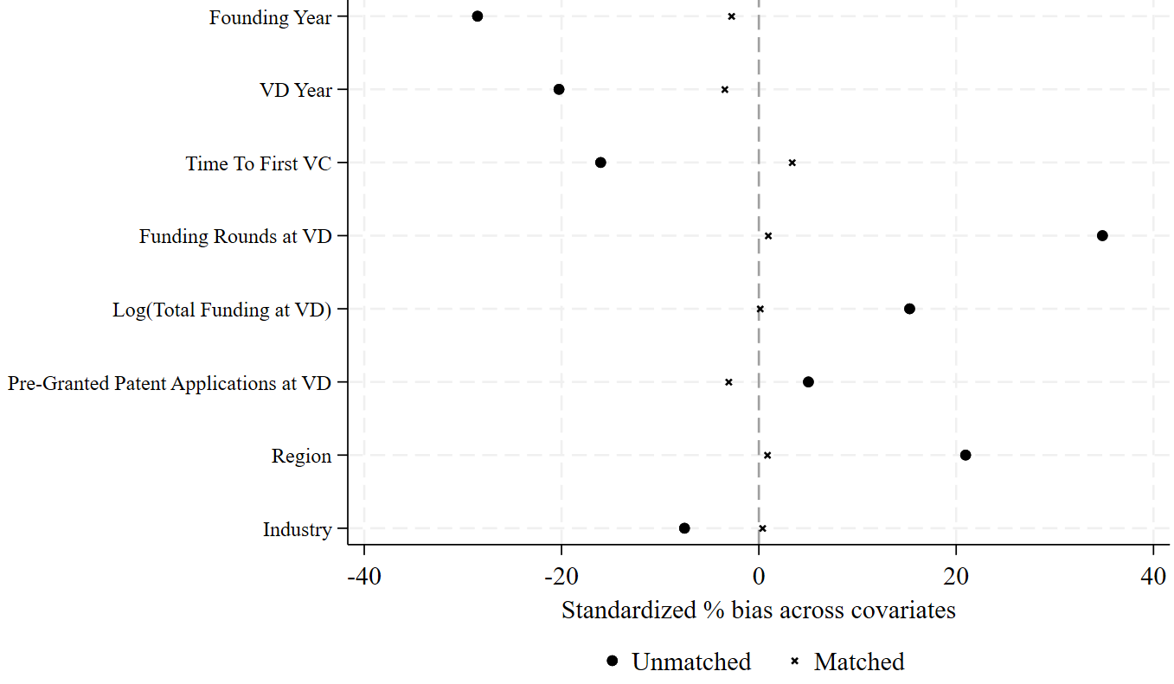

Figure A3. Estimated effect of VD on subsequent patenting by funding stage
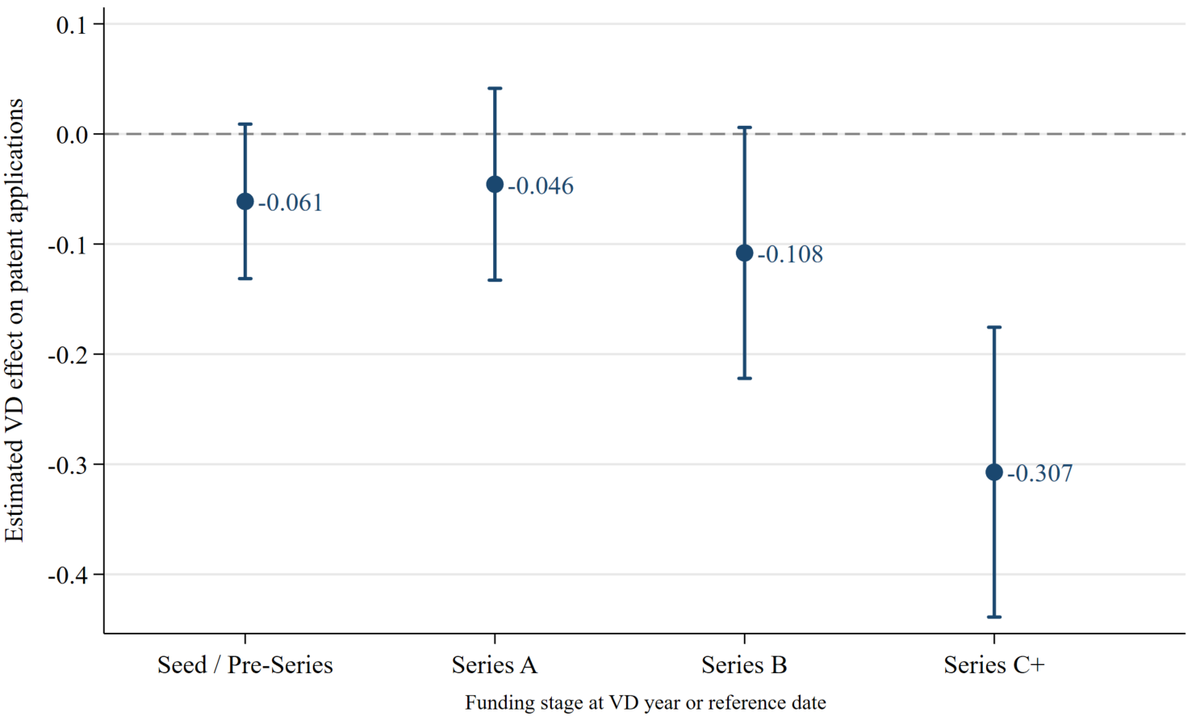

Figure A4. Diagnostic analysis for the staggered DID Design
(a) Mean plots of granted patent applications per firm-year
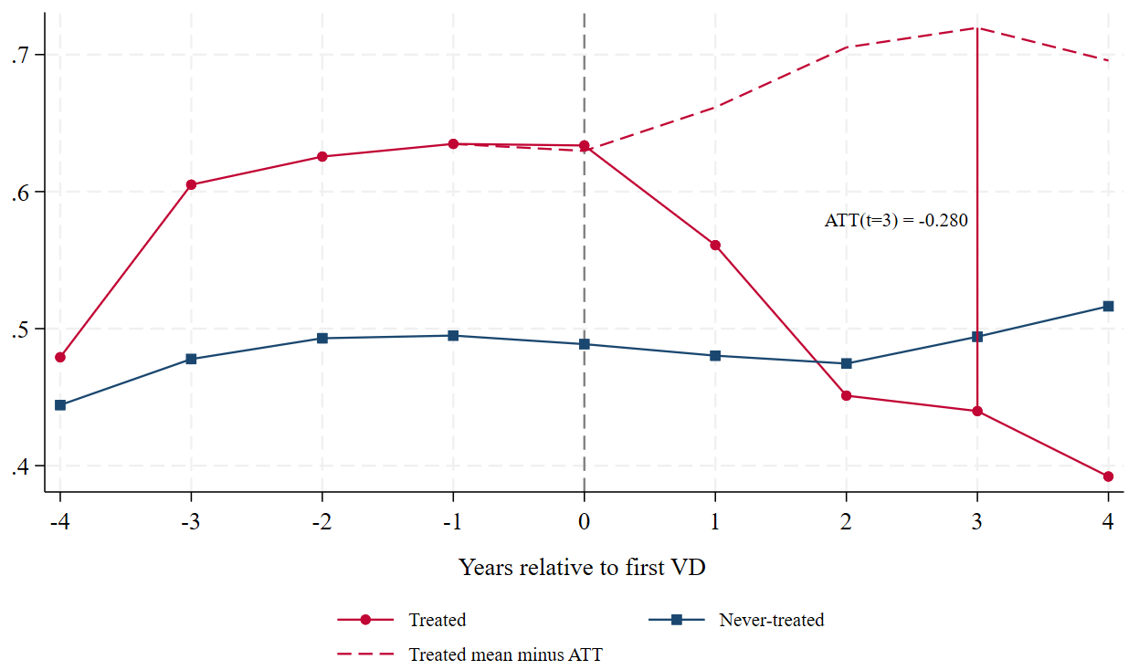
(b) Callaway-Sant’Anna event study
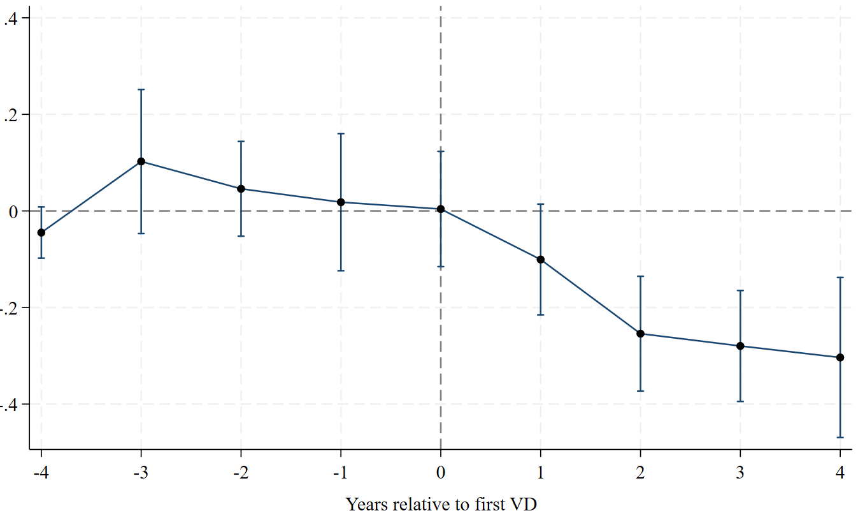
Note: Panel A shows observed and estimated counterfactual outcome trajectories while Panel B demonstrates Callaway–Sant’Anna event-study estimates. Panel A shows the mean annual number of ultimately granted patent applications for VD-backed and VC-only-backed firms relative to the year of first VD. The red dashed line represents the estimated counterfactual trajectory for VD-backed firms in the absence of VD, constructed using the Callaway and Sant’Anna (2021) event-time ATT estimates. Panel B reports the event-time ATT estimates, with vertical bars representing 95% confidence intervals. The horizontal line denotes zero treatment effect. Event time is defined relative to the year of first VD, with t=0 indicating the first VD year. Never-treated firms serve as the comparison group.
Figure A5. Heterogeneous event study estimates of the effects of VD on granted patent applications
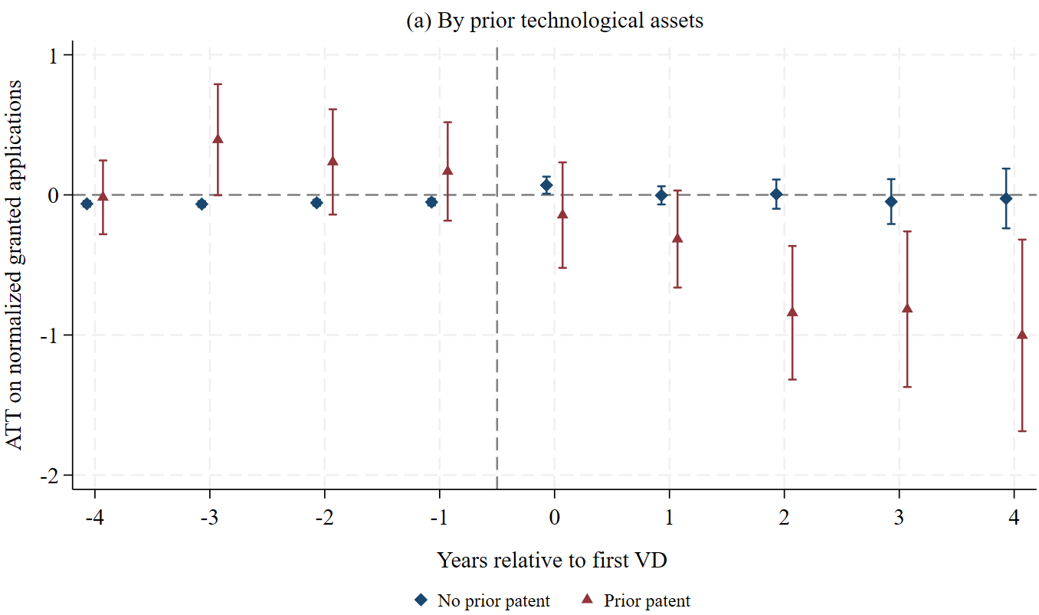
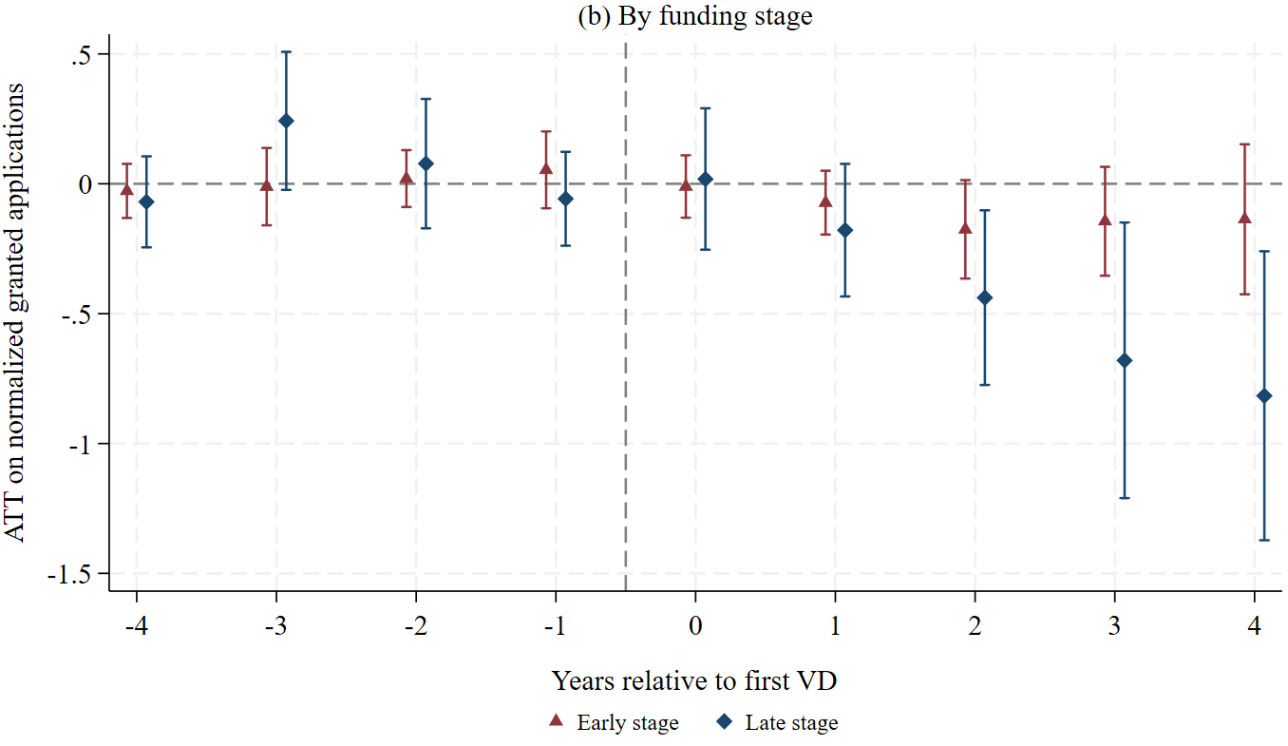
Note: This figure presents heterogeneous event study estimates of the effects of VD on granted patent applications by prior patent status (Panel a) and funding stage (Panel b). Event time is relative to the first VD financing, with t= -1 as the omitted reference period. Bands indicate 95% confidence intervals based on firm-level clustered standard errors.

Figure A6. Event study estimates across alternative estimators
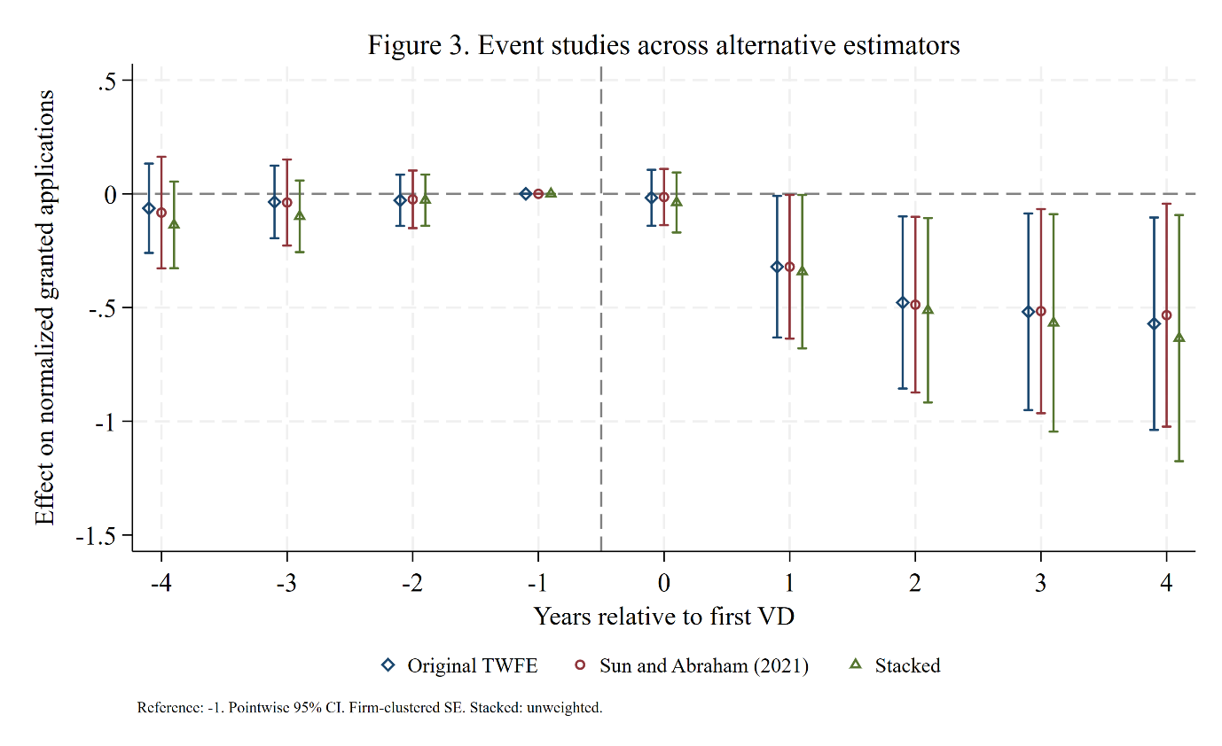
Note: This figure shows event time estimates from a fully saturated event study specification using three alternative estimators. The treatment indicator, VD, is interacted with indicators for each year relative to a firm’s first VD indicator, with t = −1 serving as the omitted reference period. All specifications include firm and year fixed effects and the full set of time varying controls used in the main analysis. Never-treated firms serve as the comparison group. Bands indicate 95% confidence intervals constructed from firm-level clustered standard errors. The p-value from an F-test of joint significance on the original TWFE pre-trend estimates is 0.857.

